CSE 210 Assignment: Explain Encapsulation
Thomas A Gibb
26 May 2026
- Explain the meaning of Encapsulation:
  - This is a functionality that provides a method to make your application more secure and reduce the possibility of having someone hack your code and change the meaning and functionality of your processes.
  - This provides a minimum of security and can help you to validate the information that you enter or that a client will enter as you strive to input parameter checks
- Highlight the benefit of Encapsulation:
  - It helps to ensure that the console entries are correct and will not cause a malfunction in your code.
  - Also helps to validate your processes and helps to keep some of your thought process organized as you design and facilitate your working environment.
- Provide and application of Encapsulation.
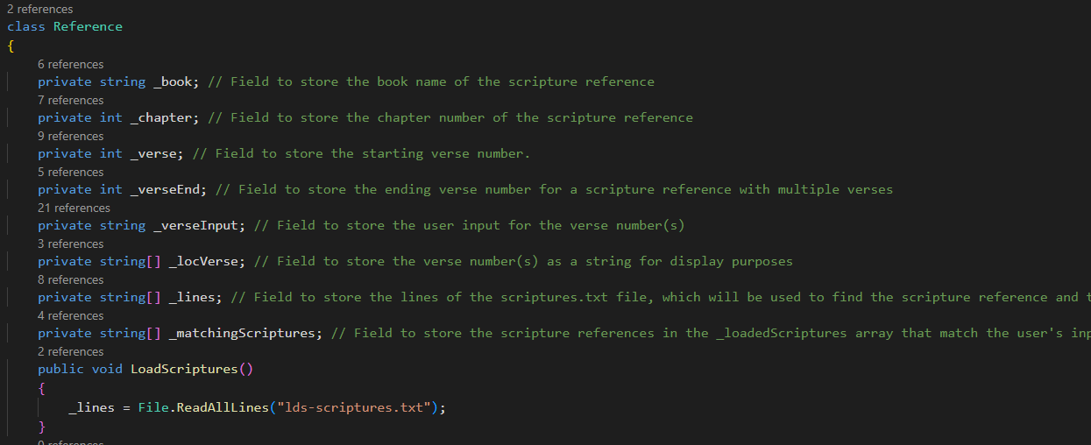
- The above is an example of the ‘private’ function of my code as well as the “public void LoadScriptures()” function that simplifies the process of loading the scripture source that I have chosen to load into the private variable “_lines”.
- This makes it easy to validate that the chosen scriptures are already loaded and that I do not have to reload them during their usage in various processes in the code.
- The above example also show how many times each element is used in the various C# processes and will allow me to easily locate them and validate their correct usage.

